Secure-Contain-Protect Challenge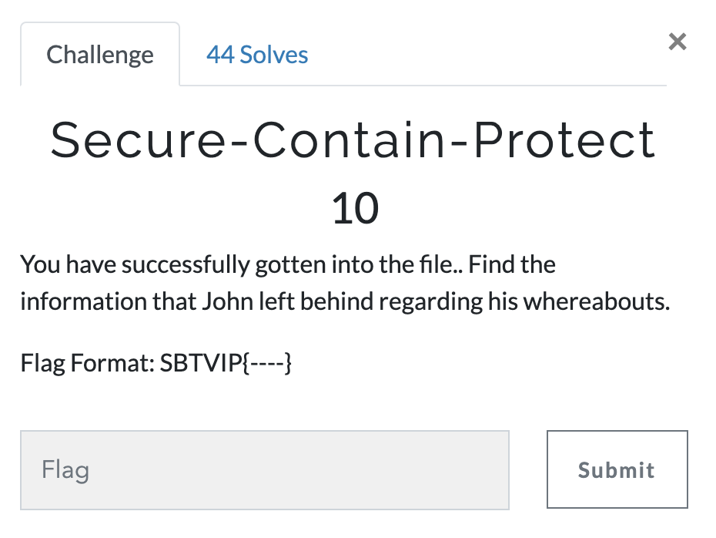
Answer: This challenge is a second part of the Switching Teams Challenge. Let start by looking at all the files that came out of admin.zip
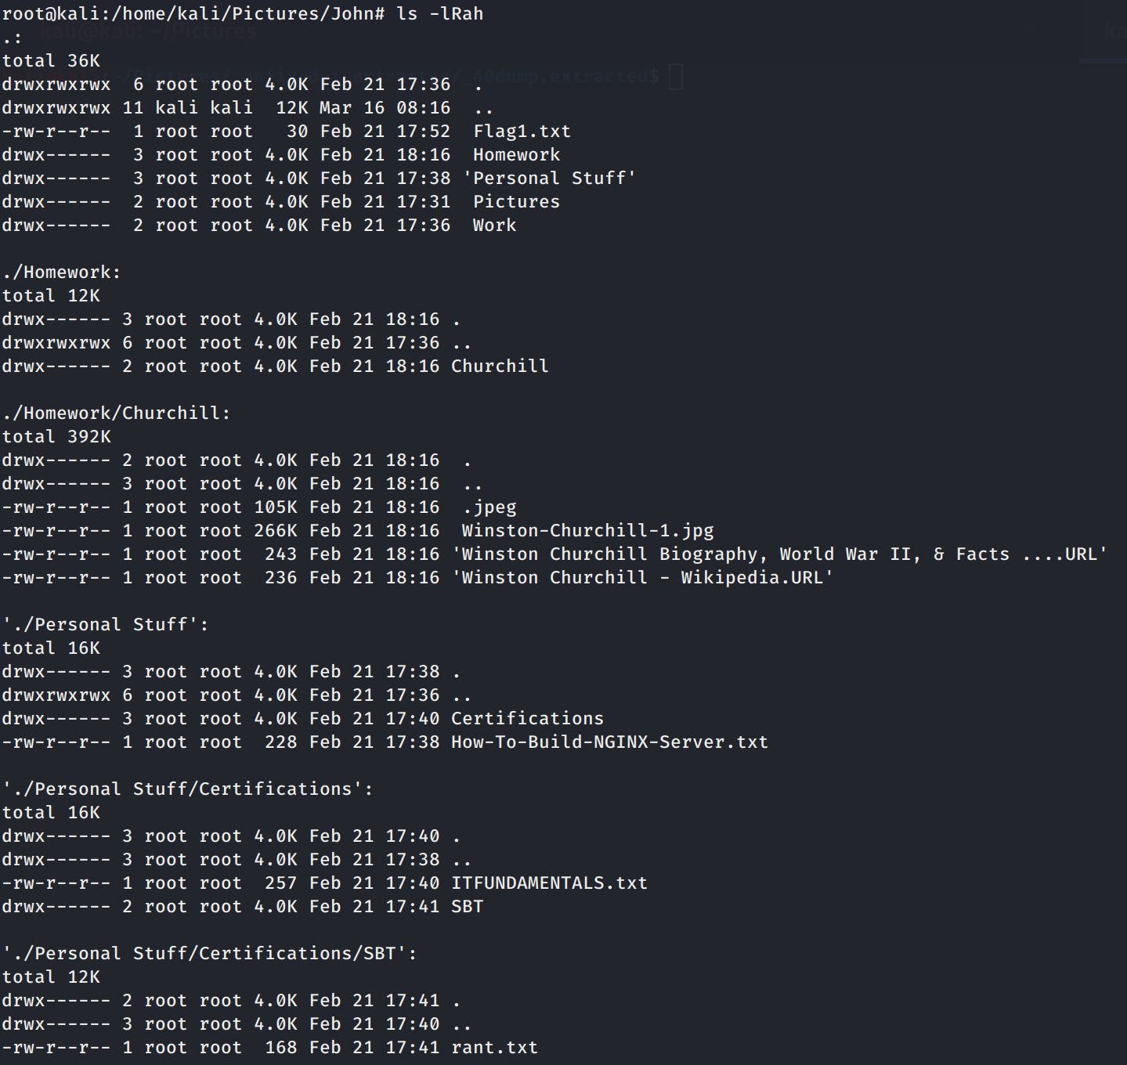
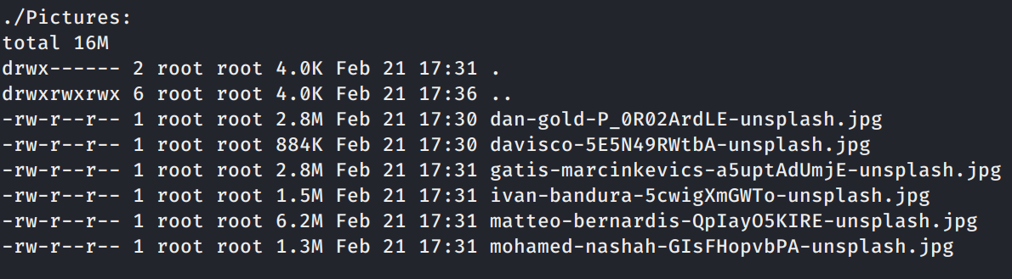
We have a few files including a hidden jpeg.
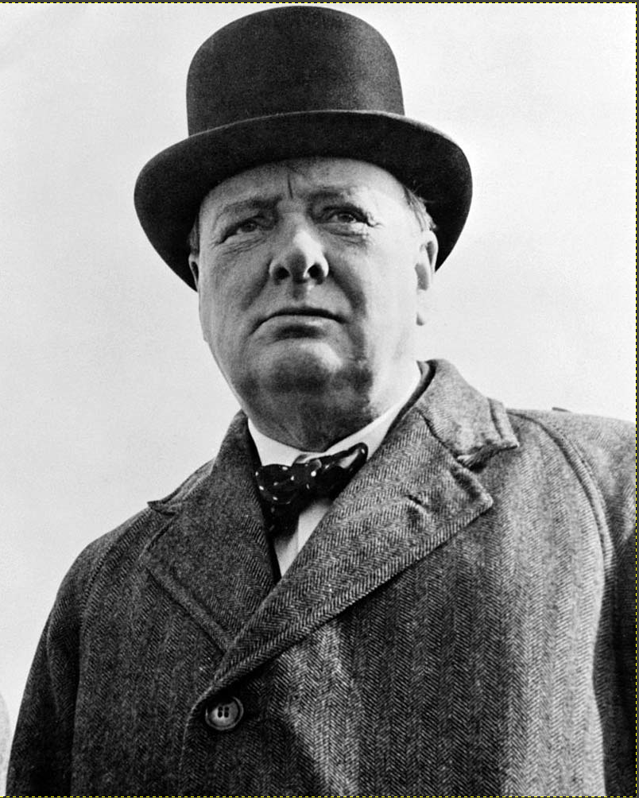
Nothing special about this image.
There are a few txt files, one of interest is the Work/To-Do.txt. Inside there is a link https://pastebin.com/DaA5uvk4
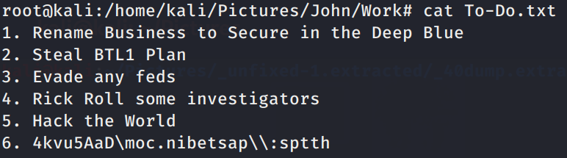
If you go to that site we see the following.
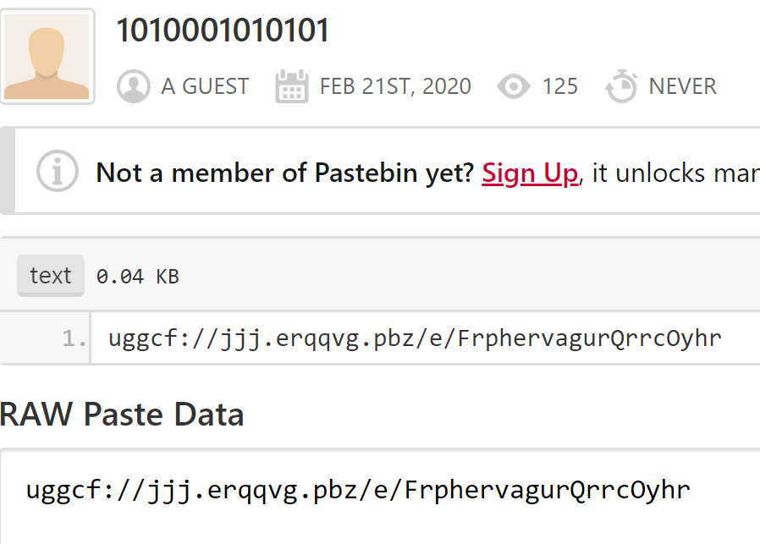
This looks to bea URL that is ROT13 encoded, let’s use hURL to decode.
Another url to a reddit page that contains some binary.
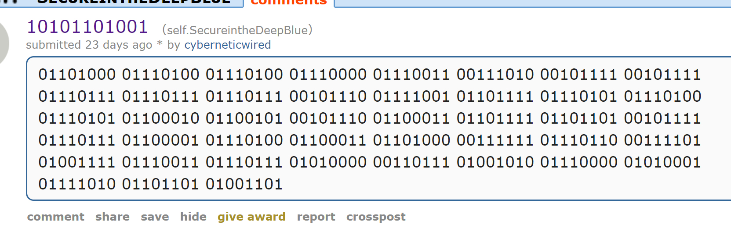
Decoding the binary give us the following. https://www.youtube.com/watch?v=OswP7JpQzmM
The YouTube video looks like a confession tape with one important frame that contains a hex string. 68 74 74 70 73 3a 2f 2f 77 77 77 2e 70 61 73 74 65 66 73 2e 63 6f 6d 2f 70 69 64 2f 31 37 39 39 37 38 decoded to https://www.pastefs.com/pid/179978
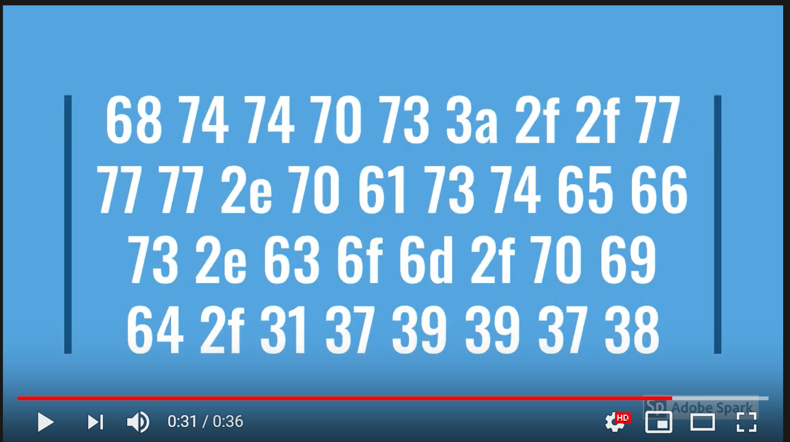
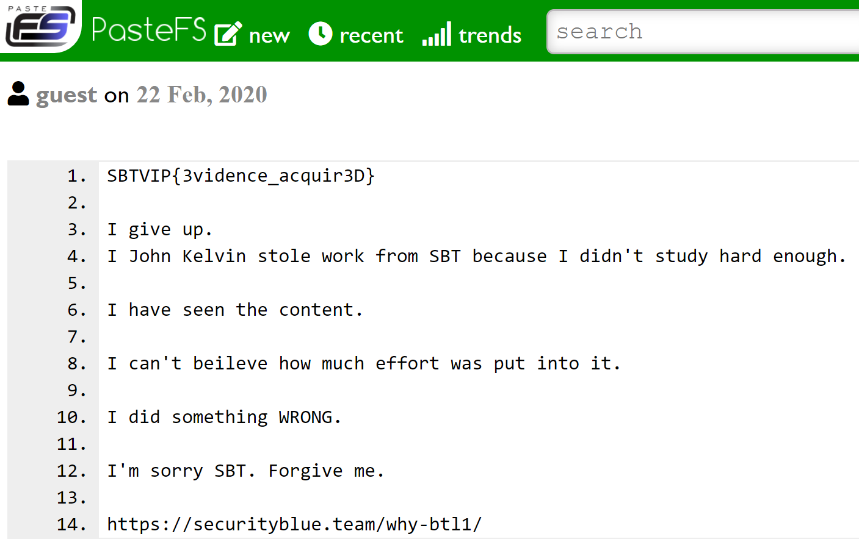
When you visit the site you see the final confession and the flag.
FLAG: SBTVIP{3vidence_acquir3D}

